**Monday** (Dave’s Van)

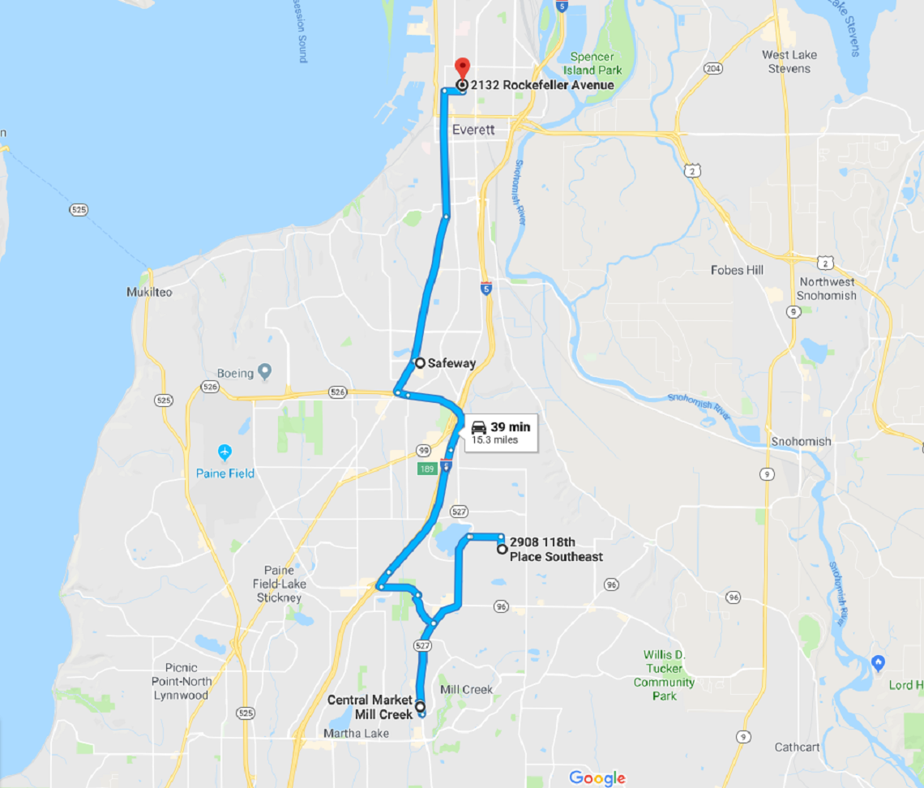

Notes: